1. Design DFA using simulator to accept the string having ‘ab’ as substring over the set {a,b}

INPUT

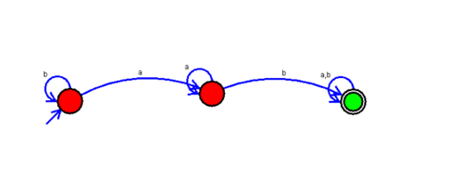

OUTPUT:

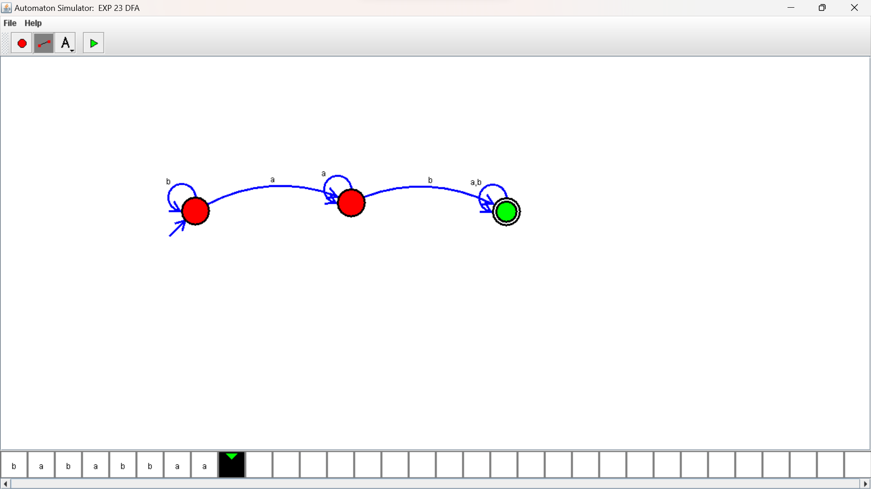

RESULTS:

DFA using simulator to accept the string having ‘ab’ as substring over the set {a,b}